Lesson 1 Welcome

1. Welcome to the Program

<https://www.youtube.com/watch?time_continue=2&v=w2lV5_S2_2A>

1. State of the Industry

<https://www.youtube.com/watch?v=eM6kMpM_bwQ>

**Flying Car Industry**

Be sure to check out Udacity's [**Flying Car Medium blog posts**](https://medium.com/udacity/tagged/flying-cars) as well as the external industry resources listed below for up to date news and insights for the Flying Car industry.

* [**Uber Elevate's whitepaper**](https://www.uber.com/elevate.pdf) on the future of on-demand aerial taxi urban air transport.
* Vertical Flight Society's [**updated list of companies**](http://evtol.news/aircraft/) developing electric vertical take-off and landing (eVTOL) aircraft.
* Dronecode's **[opensource UAV platform](https://www.dronecode.org/" \t "_blank)**.

1. Meet Andy and Jake

<https://www.youtube.com/watch?time_continue=1&v=w8MC2-6HYyU>

1. Meet your Instructors

<https://www.youtube.com/watch?v=mPGnIDXw--0>

1. Meet Raff

**Meet Raffaello D'Andrea**

**[[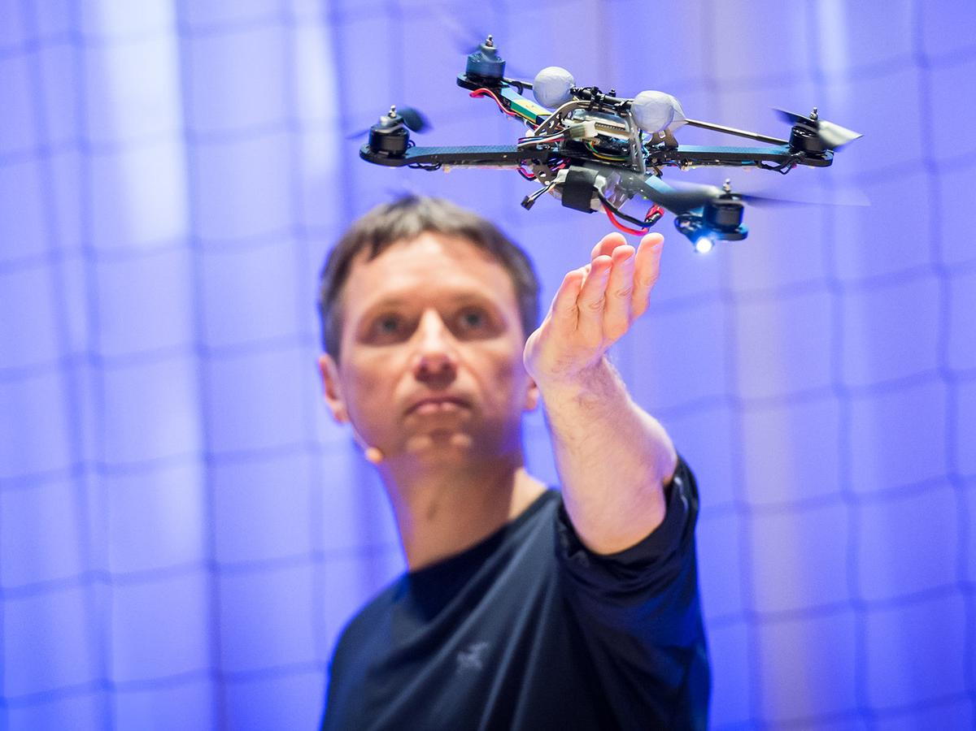](https://classroom.udacity.com/nanodegrees/nd787/parts/5aa0a956-4418-4a41-846f-cb7ea63349b3/modules/2c43620c-78cc-427f-afc1-e6e0d42f82f0/lessons/7dbdaea9-3742-4a09-8809-7785b793f7a0/concepts/dc6fc6e0-5444-4ed2-a01c-c37c33d199d9)](https://classroom.udacity.com/nanodegrees/nd787/parts/5aa0a956-4418-4a41-846f-cb7ea63349b3/modules/2c43620c-78cc-427f-afc1-e6e0d42f82f0/lessons/7dbdaea9-3742-4a09-8809-7785b793f7a0/concepts/dc6fc6e0-5444-4ed2-a01c-c37c33d199d9)**

Alongside Sebastian, Angela, and Nick, we are extremely pleased and honored to introduce Flying Car instructor Raffaello D'Andrea.

Raffaello, or Raff, is an esteemed engineer, artist, and entrepreneur. He is professor of dynamic systems and control at ETH Zurich, co-founder of Kiva Systems (now Amazon Robotics), and founder of Verity Studios. Across all ventures, Raff is a prolific inventor, with autonomous robots as his primary medium.

While Angela, Nick, and Sebastian will primarily handle classroom instruction, Raff will join to share his real-world experience and expertise throughout the program. For starters, you can view any of these conversations with Raff:

* [**Flying Car Curriculum**](https://youtu.be/kuNEtnVnTGE)
* [**Flying Cars & Self-Driving Cars**](https://youtu.be/w6bP7l2o81s)
* [**Flying Cars & Machine Learning**](https://youtu.be/ZUYHuAa9xfo)

And be sure to check out Raff's TED talk at the end of this lesson!

1. Projects You Will Build

<https://www.youtube.com/watch?time_continue=1&v=xq0gZBySFOo>

1. Student Support

**Support**

There are several ways in which you will receive support during the program from Udacity's network of Mentors and Reviewers, as well as your student community.

**Knowledge**

**Find commonly asked Questions and Answers**

Check out our forums called "Knowledge". This is where student's such as yourself post questions and get answers from the Udacity community. You can browse great answers to questions about projects, technical issues and content. Check it out by clicking the button below.

If you don't see a question that you want to be answered, go ahead and post it yourself to get a quick response!

[**KNOWLEDGE**](https://knowledge.udacity.com/?nanodegree=5ce69a5c-496f-11e8-b509-932e3a4da789&page=1)

**[[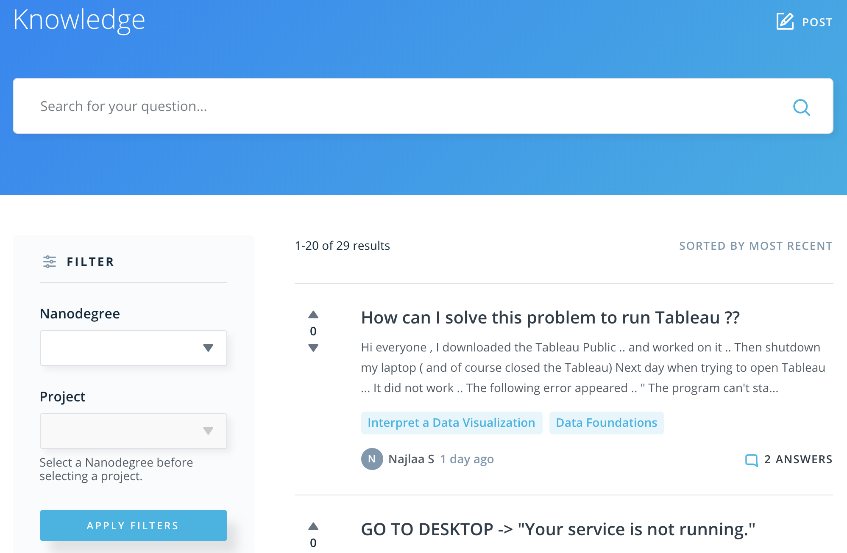](https://classroom.udacity.com/nanodegrees/nd787/parts/5aa0a956-4418-4a41-846f-cb7ea63349b3/modules/2c43620c-78cc-427f-afc1-e6e0d42f82f0/lessons/7dbdaea9-3742-4a09-8809-7785b793f7a0/concepts/f3bc62c2-07e0-4498-9a9c-80415db226cc)](https://classroom.udacity.com/nanodegrees/nd787/parts/5aa0a956-4418-4a41-846f-cb7ea63349b3/modules/2c43620c-78cc-427f-afc1-e6e0d42f82f0/lessons/7dbdaea9-3742-4a09-8809-7785b793f7a0/concepts/f3bc62c2-07e0-4498-9a9c-80415db226cc)**

You can always get back to Knowledge by clicking on the lightbulb icon on the left of your screen

**[[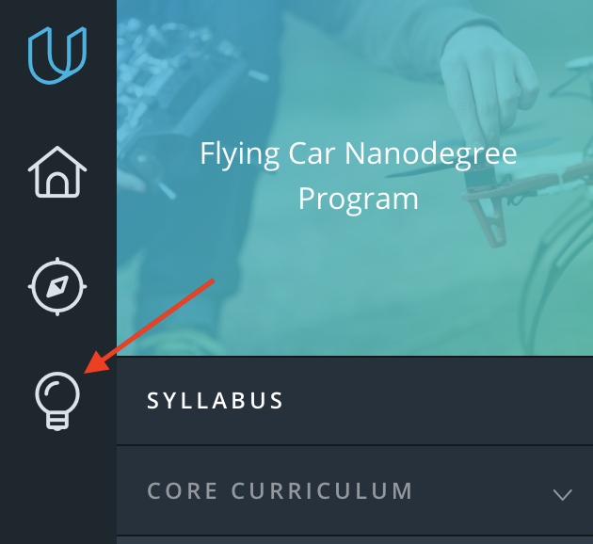](https://classroom.udacity.com/nanodegrees/nd787/parts/5aa0a956-4418-4a41-846f-cb7ea63349b3/modules/2c43620c-78cc-427f-afc1-e6e0d42f82f0/lessons/7dbdaea9-3742-4a09-8809-7785b793f7a0/concepts/f3bc62c2-07e0-4498-9a9c-80415db226cc)](https://classroom.udacity.com/nanodegrees/nd787/parts/5aa0a956-4418-4a41-846f-cb7ea63349b3/modules/2c43620c-78cc-427f-afc1-e6e0d42f82f0/lessons/7dbdaea9-3742-4a09-8809-7785b793f7a0/concepts/f3bc62c2-07e0-4498-9a9c-80415db226cc)**

**In-Classroom Mentorship**

**[[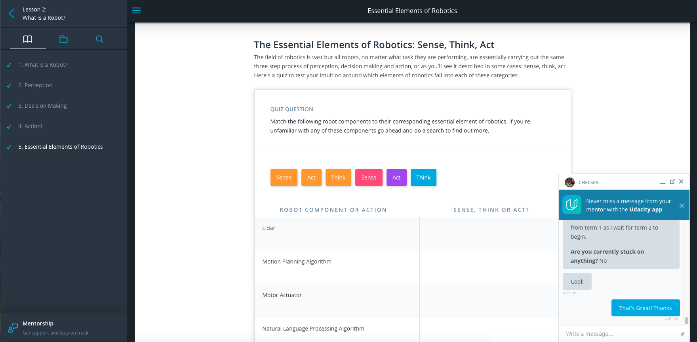](https://classroom.udacity.com/nanodegrees/nd787/parts/5aa0a956-4418-4a41-846f-cb7ea63349b3/modules/2c43620c-78cc-427f-afc1-e6e0d42f82f0/lessons/7dbdaea9-3742-4a09-8809-7785b793f7a0/concepts/f3bc62c2-07e0-4498-9a9c-80415db226cc)](https://classroom.udacity.com/nanodegrees/nd787/parts/5aa0a956-4418-4a41-846f-cb7ea63349b3/modules/2c43620c-78cc-427f-afc1-e6e0d42f82f0/lessons/7dbdaea9-3742-4a09-8809-7785b793f7a0/concepts/f3bc62c2-07e0-4498-9a9c-80415db226cc)**

In classroom Mentorship is available to you from the day you start your learning journey. You will have the option to converse with an aerial robotics expert to help answer questions you may have about the material and projects throughout the course. Your mentor will typically respond to your questions within a 24-hour period and may also ask you about your learning goals while proceeding through the course.

**Slack Community**

**[[](https://classroom.udacity.com/nanodegrees/nd787/parts/5aa0a956-4418-4a41-846f-cb7ea63349b3/modules/2c43620c-78cc-427f-afc1-e6e0d42f82f0/lessons/7dbdaea9-3742-4a09-8809-7785b793f7a0/concepts/f3bc62c2-07e0-4498-9a9c-80415db226cc)](https://classroom.udacity.com/nanodegrees/nd787/parts/5aa0a956-4418-4a41-846f-cb7ea63349b3/modules/2c43620c-78cc-427f-afc1-e6e0d42f82f0/lessons/7dbdaea9-3742-4a09-8809-7785b793f7a0/concepts/f3bc62c2-07e0-4498-9a9c-80415db226cc)**

Slack is the best place for live discussion and interaction with your community of students. If you haven't joined already, you can sign up [**here**](https://flyingcar.udacity.com/). Since the Udacity Flying Car Slack is also open to the broader flying car community, you will also be able to interact with flying car enthusiasts in the program and beyond! This will help you grow your network and see what others are doing not only in the program and but also in the autonomous flight field.

Additionally, the Udacity Team will be holding office hours and discussions in Slack to help support you along the way. See a schedule of office hours and discussions on the your class calendar:

* February class [**here**](http://bit.ly/2GBrc1H)
* March class [**here**](http://bit.ly/2G8fZGd)
* May class [**here**](http://bit.ly/2Is2ENu)

**Reviews**

**[[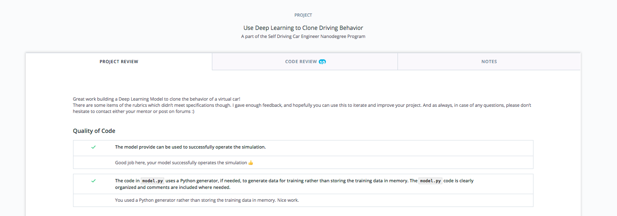](https://classroom.udacity.com/nanodegrees/nd787/parts/5aa0a956-4418-4a41-846f-cb7ea63349b3/modules/2c43620c-78cc-427f-afc1-e6e0d42f82f0/lessons/7dbdaea9-3742-4a09-8809-7785b793f7a0/concepts/f3bc62c2-07e0-4498-9a9c-80415db226cc)](https://classroom.udacity.com/nanodegrees/nd787/parts/5aa0a956-4418-4a41-846f-cb7ea63349b3/modules/2c43620c-78cc-427f-afc1-e6e0d42f82f0/lessons/7dbdaea9-3742-4a09-8809-7785b793f7a0/concepts/f3bc62c2-07e0-4498-9a9c-80415db226cc)**

For each project you submit, you will receive detailed feedback from a project Reviewer. Sometimes, a reviewer might ask you to resubmit a project to meet specifications. In that case, an indication of needed changes will also be provided. Note that you can submit a project as many times as needed to pass.

**Feedback**

**[[](https://classroom.udacity.com/nanodegrees/nd787/parts/5aa0a956-4418-4a41-846f-cb7ea63349b3/modules/2c43620c-78cc-427f-afc1-e6e0d42f82f0/lessons/7dbdaea9-3742-4a09-8809-7785b793f7a0/concepts/f3bc62c2-07e0-4498-9a9c-80415db226cc)](https://classroom.udacity.com/nanodegrees/nd787/parts/5aa0a956-4418-4a41-846f-cb7ea63349b3/modules/2c43620c-78cc-427f-afc1-e6e0d42f82f0/lessons/7dbdaea9-3742-4a09-8809-7785b793f7a0/concepts/f3bc62c2-07e0-4498-9a9c-80415db226cc)**

We value your feedback and we are constantly working to improve your experience in the classroom. In order to keep our content up-to-date and address issues quickly, we've set up a [**Waffle board**](https://waffle.io/udacity/fcnd-issue-reports) to track error reports and suggestions.

**[[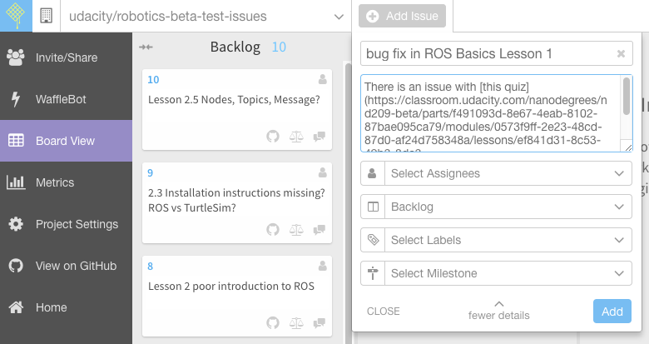](https://classroom.udacity.com/nanodegrees/nd787/parts/5aa0a956-4418-4a41-846f-cb7ea63349b3/modules/2c43620c-78cc-427f-afc1-e6e0d42f82f0/lessons/7dbdaea9-3742-4a09-8809-7785b793f7a0/concepts/f3bc62c2-07e0-4498-9a9c-80415db226cc)](https://classroom.udacity.com/nanodegrees/nd787/parts/5aa0a956-4418-4a41-846f-cb7ea63349b3/modules/2c43620c-78cc-427f-afc1-e6e0d42f82f0/lessons/7dbdaea9-3742-4a09-8809-7785b793f7a0/concepts/f3bc62c2-07e0-4498-9a9c-80415db226cc)**

If you find an error, go to the Waffle board and file an issue by clicking on the "Add issue" button (you will need a GitHub account for this). Give your issue a descriptive title, and include the details of the issue in the body of the message. Links and screenshots, if available, are always appreciated!

**QUIZ QUESTION**

Have you signed up for Slack?

* 

Yes

* 

No

SUBMIT

NEXT

1. Deadline Policy

**Deadline Policy**

When we use the term “deadline” with regards to Nanodegree program projects, we use it in one of two ways:

* A final deadline for passing all projects
* Ongoing suggested deadline for individual projects

It is very important to understand the distinctions between the two, as your progress in the program is measured against the deadlines we’ve established. Please see below for an explanation of what each usage means.

**A final deadline for passing all projects**

Passing a project in this context means that a Udacity Reviewer has marked your project as “Meets Specifications.” In order to graduate a term, you have to pass all projects by the last day of the term.

If you do not pass all projects by the last day of the term, the following happens:

* You will receive a 4-week extension to complete any outstanding projects. You will receive this extension a maximum of one time. Once you submit and pass all projects, you can enroll in the next term, which will potentially be with a later class. If you do not submit and pass all projects within the 4-week extension, you will be removed from the program.

**Ongoing suggested deadlines for individual projects**

**[[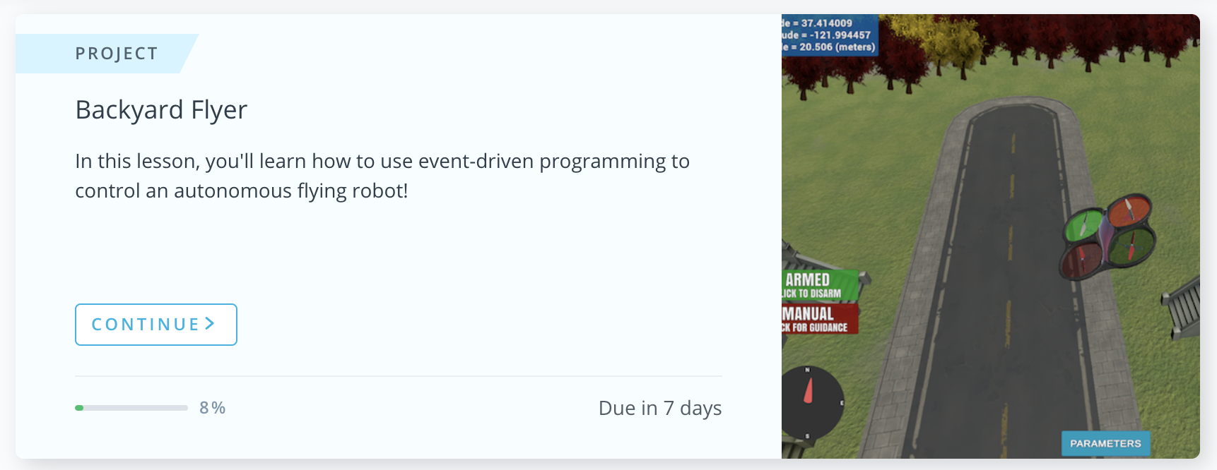](https://classroom.udacity.com/nanodegrees/nd787/parts/5aa0a956-4418-4a41-846f-cb7ea63349b3/modules/2c43620c-78cc-427f-afc1-e6e0d42f82f0/lessons/7dbdaea9-3742-4a09-8809-7785b793f7a0/concepts/1274ff1c-933a-40e2-ae0b-8cae41d4a832)](https://classroom.udacity.com/nanodegrees/nd787/parts/5aa0a956-4418-4a41-846f-cb7ea63349b3/modules/2c43620c-78cc-427f-afc1-e6e0d42f82f0/lessons/7dbdaea9-3742-4a09-8809-7785b793f7a0/concepts/1274ff1c-933a-40e2-ae0b-8cae41d4a832)**

The deadlines you see in your classroom are suggestions for when you should ideally pass each project. They are meant to help keep you on track so that you maintain an appropriate pace throughout the program—one that will see you graduate on time!

Please note that you can submit your project as many times as you need to. There are no penalties if you miss these deadlines. However, you will be at risk of not passing all projects on time if you miss these deadlines, and fall behind, so it is a recommended best practice to try and meet each suggested deadline.

**Project Deadlines by Cohort**

**February class**

| **Project** | **Due Date** |
| --- | --- |
| Backyard Flyer | Mar 6 |
| 3D Motion Planning | Apr 3 |
| Control of a 3D Quadrotor | May 1 |
| Building an Estimator | May 29 |
| Final Term Deadline | June 12 |

**We highly recommend adding these deadlines to your calendar.** You can do this in two ways:

* Download the ICS file [**here**](http://bit.ly/2CDsO8O) and import it into whatever calendar you use.
* Open up the Project Deadlines Google Calendar [**here**](http://bit.ly/2GBrc1H) and click the + button in the bottom right hand corner to add it to your Google Calendar.

**March class**

| **Project** | **Due Date** |
| --- | --- |
| Backyard Flyer | Apr 3 |
| 3D Motion Planning | May 1 |
| Control of a 3D Quadrotor | May 29 |
| Building an Estimator | June 26 |
| Final Term Deadline | July 10 |

**We highly recommend adding these deadlines to your calendar.** You can do this in two ways:

* Download the ICS file [**here**](http://bit.ly/2GgcQaH) and import it into whatever calendar you use.
* Open up the Project Deadlines Google Calendar [**here**](http://bit.ly/2G8fZGd) and click the + button in the bottom right hand corner to add it to your Google Calendar.

**May class**

| **Project** | **Due Date** |
| --- | --- |
| Backyard Flyer | May 22 |
| 3D Motion Planning | June 19 |
| Control of a 3D Quadrotor | July 17 |
| Building an Estimator | Aug 14 |
| Final Term Deadline | Aug 28 |

**We highly recommend adding these deadlines to your calendar.** You can do this in two ways:

* Download the ICS file [**here**](http://bit.ly/2I3yCMp) and import it into whatever calendar you use.
* Open up the Project Deadlines Google Calendar [**here**](http://bit.ly/2Is2ENu) and click the + button in the bottom right hand corner to add it to your Google Calendar.

Read the Deadline Policy

Task List

* 

Yes, I have read the deadline policies and understand the consequences of not completing the program on time.

NEXT

1. Class Schedule

**Staying on Track**

**Class Schedule by Cohort**

Our class schedule PDF will help you stay on track to graduating. Remember, the suggested project deadlines are flexible but the end of term deadline is not. In order to graduate, you will need to pass all projects by the final end of term deadline. If you fall behind the suggested project deadlines, you can use the class schedule to prioritize which lessons are most relevant to completing the projects before your term ends. Note that you are free to work ahead of the class schedule.

You may view and download the class schedule for your cohort below:

* February Class Schedule [**here**](http://bit.ly/2EpJLEO)
* March Class Schedule [**here**](http://bit.ly/2DWQRQP)
* May Class Schedule [**here**](http://bit.ly/2I6NsBO)

*Note: Office Hours are tentative dates. We will announce any changes in*[***Slack***](https://flyingcar.udacity.com/)*and update your Class Schedule and Google Calendars.*

For additional information about the program, check out our [**Resource Guide**](http://bit.ly/2pHiOb3)!

NEXT

1. Learning at Udacity

**Learning at Udacity**

**[[](https://classroom.udacity.com/nanodegrees/nd787/parts/5aa0a956-4418-4a41-846f-cb7ea63349b3/modules/2c43620c-78cc-427f-afc1-e6e0d42f82f0/lessons/7dbdaea9-3742-4a09-8809-7785b793f7a0/concepts/5715791f-a8ca-466e-816e-61c7711b72f8)](https://classroom.udacity.com/nanodegrees/nd787/parts/5aa0a956-4418-4a41-846f-cb7ea63349b3/modules/2c43620c-78cc-427f-afc1-e6e0d42f82f0/lessons/7dbdaea9-3742-4a09-8809-7785b793f7a0/concepts/5715791f-a8ca-466e-816e-61c7711b72f8)**

If you're a seasoned Udacity student then you most likely already have a plan for how you'll carve out time to work through the lessons and projects in this program. If you're new to Udacity, the structure and pace of the program might take some getting used to. Whether you've studied with us before, or this is your first time in the Udacity classroom, we'd like to share some details with you here about this program, as well as some tips and suggestions for charting a path to a successful graduation.

**Expected time commitment**

We suggest you plan to spend 15 hours per week working on this program. That said, everyone moves at a different pace through the content, which is largely determined by the skills you come into the program with, and how deep you dive into exploring these subjects beyond the lessons in the classroom. Be deliberate! Put your study time on your calendar, and plan to do a little bit every day rather than pushing through large amounts of work at the last minute.

**Classroom lessons vs. projects**

You will be going through lessons in the Udacity classroom that give you the tools you need to complete the projects. However, the projects are where the real learning takes place and where you will spend the majority of your time in this program. Start the projects early and reach out to your fellow students in Slack or to the mentors in the classroom when you get stuck.

**Access to content on your mobile device**

While you can access the Udacity classroom on your mobile device, the lessons in this program will include numerous hands-on exercises like programming quizzes or following along with a demonstration in a virtual machine. So feel free to catch up on the text and video content on your mobile device while on the train ride home, but you'll get much more out of the interactive content on your personal computer.

**QUIZ QUESTION**

How many hours a week should you plan to spend on this program and what fraction of that time will you spend on the projects?

* 

Exactly 15 hours per week, the majority of total time on projects

* 

Roughly 5 hours per week, the majority of total time on classroom content

* Roughly 15 hours per week, the majority of total time on projects
* 

Roughly 15 hours per week, the majority of total time on classroom content

SUBMIT

NEXT

1. Community Code of Conduct

**Community Code of Conduct**

Your experience in the Nanodegree program and community should be an engaging, fulfilling, and positive one. As such, we have outlined the following system for reporting behavior that does not live up to Udacity’s standards, so it can quickly be addressed by our staff.

All reports of suspected violations to the [**TOU**](https://www.udacity.com/legal/terms-of-service), [**Community Code of Conduct**](https://www.udacity.com/legal/community-guidelines) or [**Honor Code**](https://www.udacity.com/legal/community-guidelines) should be submitted to [**report@udacity.com**](mailto:report@udacity.com) and will be reviewed. If you witness or are experiencing any violations of our policies please get in touch with us. Below prohibited actions as set forth on our [**Community Code of Conduct**](https://www.udacity.com/legal/community-guidelines):

* **Harassment:** Inappropriate, harassing, abusive, discriminatory, derogatory or violent comments or conduct.
* **Discrimination:** Offensive comments related to gender or gender identity, sexual orientation, race, ethnicity, religion, national origin, disability or disease
* **Distributing inappropriate content:** Use of sexual, violent, graphic, or derogatory images
* **Bullying:** Deliberate intimidation, threats of violence or violent language directed against another person
* **Sexual harassment:** Unwelcome sexual attention
* **Defamation:** Obscene, fraudulent, indecent, or libelous acts that defame, abuse, harass, discriminate against or threaten others
* **Plagiarism:** will not cheat on any homework assignment, projects or exams for the Online Courses and, specifically, will not plagiarize materials created by others
* **Self-injury or Suicide:** We do not encourage community postings in Slack or Forums related to self-injury or suicide. If you or someone you know is exhibiting signs of self-injury or suicide, find help at the [**Suicide Prevention Lifeline**](https://suicidepreventionlifeline.org/) in the U.S. and [**Befrienders.org**](https://www.befrienders.org/) globally.

When a potential violation is brought to our attention, we will make every effort to investigate the case thoroughly and make a decision that is fair to all parties.

Thank you,

The Udacity Team

NEXT

1. Your Flying Car Community

<https://www.youtube.com/watch?time_continue=1&v=jYPBHNrv0yk>

1. Astounding Flying Machines (Optional)

<https://www.ted.com/talks/raffaello_d_andrea_the_astounding_athletic_power_of_quadcopters?language=zh-tw>